BUSA3003 - BUSINESS Process ModellinG
Smart City – Parking Track “Park Mate”

Thien Mai Do – 3424778 | Gia Han Doan – 3444278 | Mabel Le – 3443933
University of Newcastle

EXECUTIVE SUMMARY
The report introduces Park Mate as a smart mobile parking solution which solves urban parking problems in Australian metropolitan areas. The research applies Design Thinking methods (Empathize–Define–Ideate) to discover user difficulties with confusing pricing systems and separate parking management systems. The system combines IoT sensors with AI analytics and LPR technology to show instant parking status and enable users to book spaces and make digital payments. The business model operates through service fee collection and subscription services and strategic partnership development. The system provides advantages to users and operators and councils through enhanced accessibility and better space management and support for smart transportation initiatives. The recommendations emphasize the need for strategic alliances and AI-based expansion methods.

INTRODUCTION
Urban parking inefficiency has become a critical issue in rapidly growing Australian cities such as Sydney and Newcastle. The search for parking spaces by drivers leads to 15-20 minutes of wasted time which creates traffic congestion and increases fuel consumption and decreases urban transportation efficiency (Battaglia & Battaglia, 2025). The problems with parking create two main effects which negatively impact urban economic growth and environmental sustainability of cities that aim to develop into smart sustainable cities. Addressing this problem is crucial not only for enhanced daily travel experiences but also for supporting Smart City development through sustainability initiatives and digital transformation and data-driven urban planning.

The primary aim of this report is to design and propose a smart, user-centric digital solution which uses technological advancements to solve urban parking problems. Specifically, the project develops Park Mate as a mobile application which uses IoT sensors, GPS tracking and predictive analytics to show real-time parking availability and perform automated booking and payment functions.
The key objectives are to:
- Understand user pain points through a Design Thinking framework (Empathize, Define, Ideate)
- Develop an intelligent parking system architecture that integrates data analytics, automation, and user-friendly design principles.
- Illustrates how Park Mate improves efficiency, accessibility, and sustainability in metropolitan areas.
The joint value proposition of Park Mate enables all stakeholders to receive common advantages. For drivers, the platform provides real-time parking visibility, clear pricing details and convenient digital transaction capabilities. For operators and city councils, it helps to achieve better space management while boosting revenue performance and delivering essential data for urban development planning. The platform unites users with providers and authorities through its intelligent system to create better mobility while decreasing traffic and supporting environmentally friendly urban development.

METHOD
To address the complex problem of inefficient urban parking, this study applies a Design Thinking framework in the solution development process, which includes 3 stages: Empathize, Define, Ideate. This framework provides an iterative, human-centered approach that integrates creativity, empathy, and problem-solving, which is particularly suitable for developing user-oriented digital applications such as Park Mate (Friis Dam & Siang, 2021).

Empathy
The first stage involved building empathy with the target users, drivers in major Australian cities, including students, commuters, seniors, and people with disabilities, and delivery drivers. According to Kwon et al. (2019), the empathy stage allows designers to gain a deeper understanding of users’ real-life experiences and emotional responses.
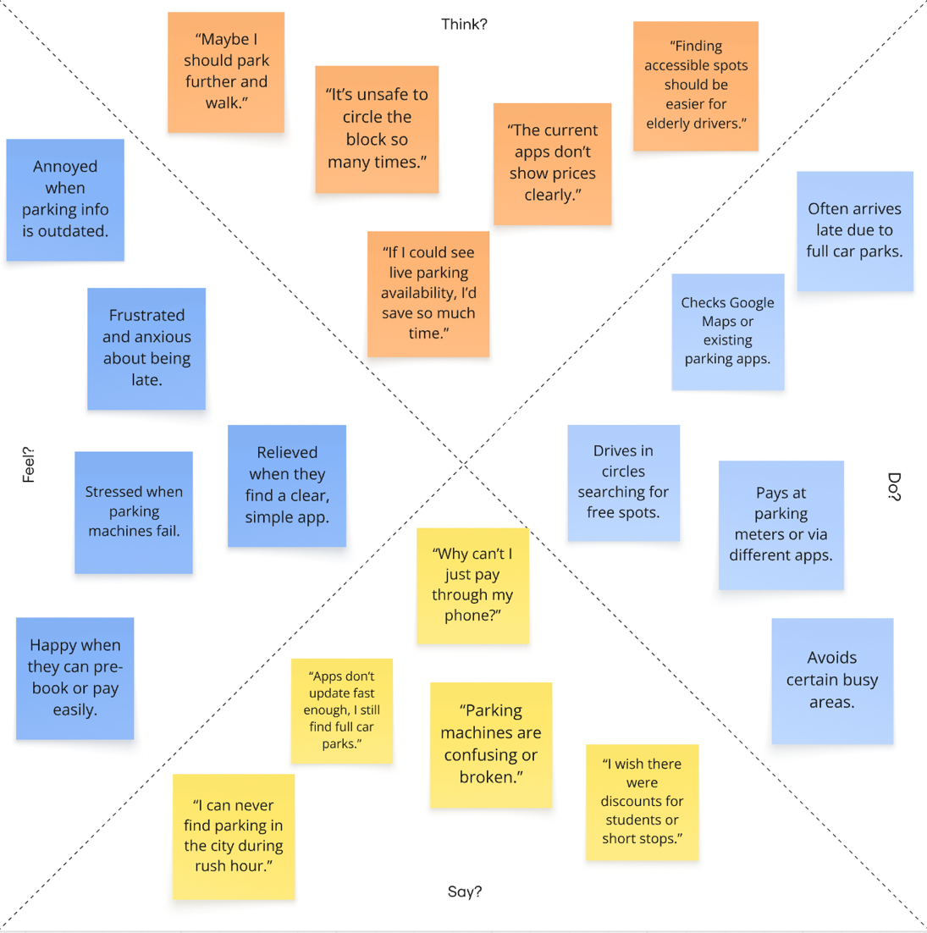
Figure 1: Empathy map

At this stage, this study used Empathy Mapping to capture what users say, think, do, and feel when searching for parking. The results showed that drivers frequently felt frustrated, anxious, and time-pressured due to unclear pricing, unreliable data, and fragmented applications. For example, users expressed that parking apps “never show the correct parking spot” and “the payment system is confusing”.

Through this, user pain points such as lack of real-time updates and poor accessibility are understood, and benefits such as the need for accurate live maps, quick payments, and predictive information are identified to provide timely solutions. Therefore, the empathy stage ensures that the proposed solution aligns with the real needs of the users (Brown & Wyatt, 2010).

Define
After collecting user data, we continued to synthesize the findings to define a clear, user-centric problem statement. This phase focused on reframing the disparate insights into a coherent design challenge: “Urban drivers in Australian cities are struggling to find affordable, accessible, real-time parking options due to inconsistent information systems, unclear pricing, and a lack of integration.” The Define phase drew from the Empathize work to generate actionable design goals and criteria (Bender-Salazar, 2023).

Ideation
Next, the Ideation phase focuses on brainstorming innovative solutions to the identified problem. Design Thinking literature emphasizes that the ideation process allows for lateral thinking before narrowing down to viable ideas (Kwon et al., 2019; Friis Dam & Siang, 2021).

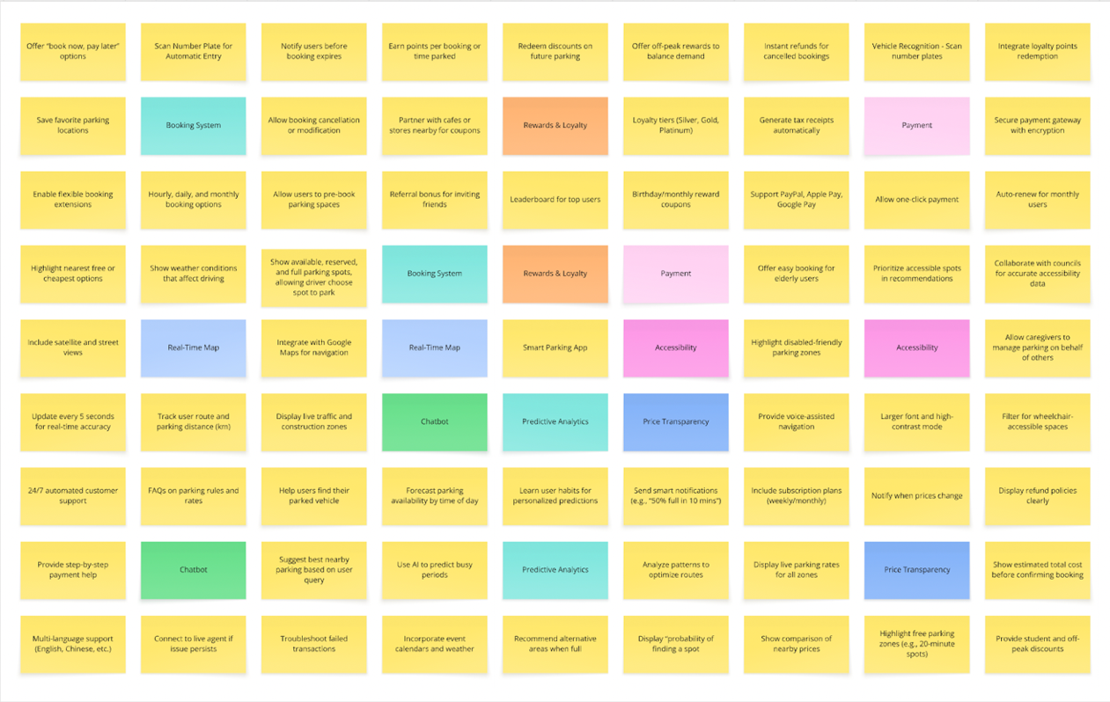
Figure 2: LOTUS Blossom Diagram
The LOTUS Blossom Diagram was chosen at this stage to help visually expand the ideas. The central theme, Smart Parking (Park Mate), is branched into eight Level 1 ideas, including: Real-Time Parking Map, Booking System, Chatbot Support, Predictive Analytics, Price Transparency, Accessibility Features, Payment Integration, Rewards & Loyalty.

Following Level 1 ideas, each idea is then further expanded into Level 2 sub-concepts, such as live traffic overlays, student discounts, and AI-driven parking availability forecasting. This structured ideation method ensured we covered broad creative ground while maintaining focus on user needs and feasibility.

RESULTS AND IMPLICATIONS

AS-IS Process

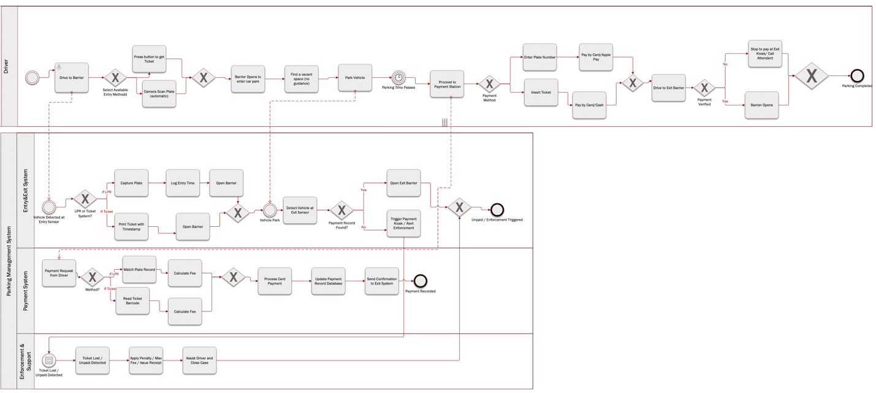
Figure 3: AS-IS process of the Current Off-Street Parking System in Newcastle

The parking system at Newcastle off-street facilities uses a ticket-based or LPR (License Plate Recognition) system which operates with semi-automated functionality. The process starts when drivers reach the entry barrier to receive either a ticket or automatic license plate scanning. The entry barrier opens after the system verifies the information. Drivers need to visit a pay station after parking their vehicles before they can leave the facility. Users can complete their payments through card transactions and mobile wallet and cash payments. The system checks payment records at the exit before allowing barrier access when payments are valid; drivers must seek help from support staff or use the exit kiosk when payments fail. The system enforces penalties for unpaid tickets and lost tickets requires human intervention to resolve these cases.

While the system maintains fundamental operations and financial revenue, it remains fragmented and unconnected system. Data exchange between the entry, payment, and enforcement systems is not fully integrated, which prevents complete analytics and creates operational challenges. From a strategic perspective. The current process supports partially the Smart Mobility and Digital Transformation goals which the City Council has established (City of Newcastle, 2023). The council faces challenges in achieving its data-driven sustainable user-focused transport system because the current process depends on manual payment stations and lacks real-time monitoring and predictive management capabilities.

TO-BE Process
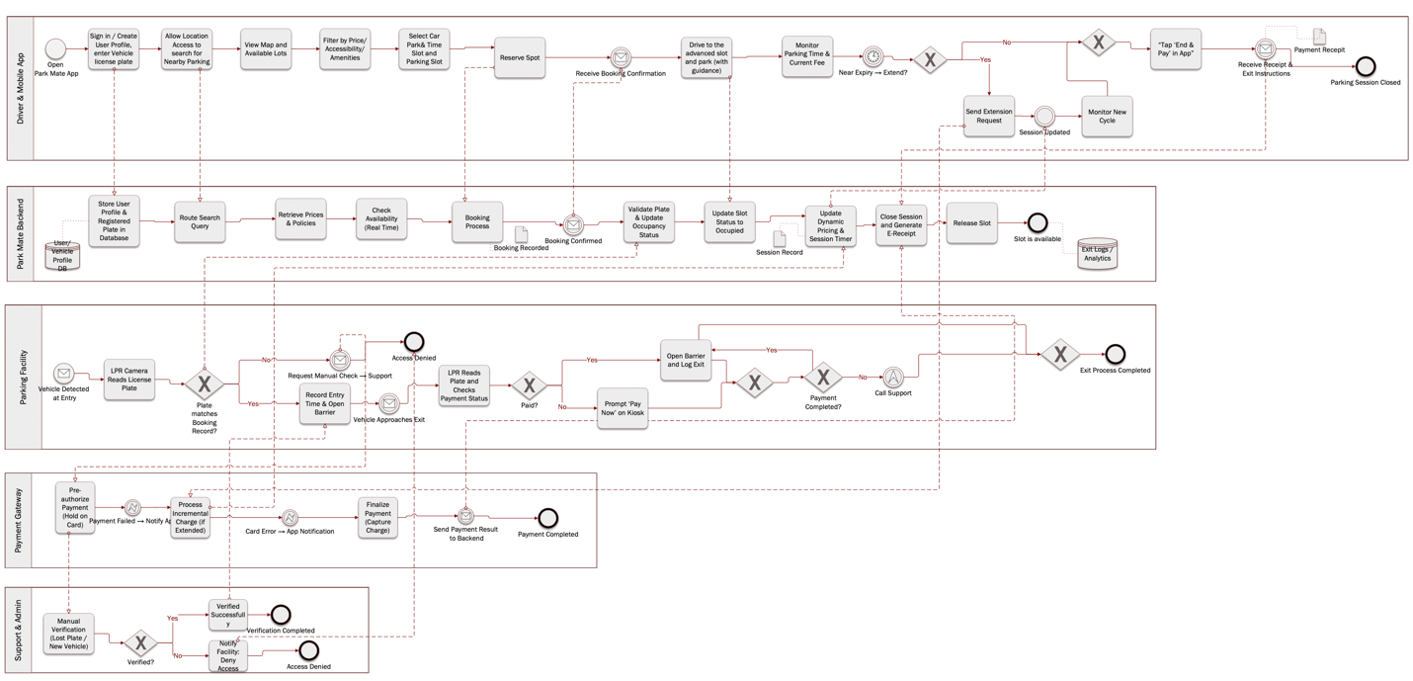
Figure 4: TO-BE Process of Park Mate Smart Parking System

The Park Mate application enables the proposed TO-BE process to transform the current parking system into a complete data-based operational framework. The process starts when a driver launches the Park Mate mobile application to create their user account and search for available parking spots. The backend shows available slots, applies real-time pricing rates, and confirms their booking request. The License Plate Recognition (LPR) system verifies reservations automatically when drivers arrive which triggers the barrier to open without human intervention. The backend system maintains ongoing updates for parking sessions and pricing rules while users access session details and payment extension options through their mobile application. The system performs automatic payment collection from digital wallets at exit points before activating the barrier for a successful transaction.

The new process structure matches the objectives which Newcastle City Council has established for Smart Mobility and sustainability goals (City of Newcastle, 2025). The Council has already adopted digital solutions such as the EasyPark app, which uses for on-street parking payment processing and session management and it does not link with off-street utilities and lacks predictive analytics and central data sharing capabilities City of Newcastle (2013). Meanwhile, Park Mate provides automated systems which deliver real-time analytics to help decrease traffic congestion and air pollution while reducing enforcement duties. The Park Mate system unites IoT sensors with digital payment functionality and AI-based analytics to create a single data-based platform which supports the city's digital transformation initiative.

Business Model
The Park Mate solution strives to modernize urban parking management through a smart platform that facilitates drivers in locating, reserving, and paying for parking spots efficiently and conveniently, with the purpose of reducing the time spent searching for parking, alleviating traffic congestion in metropolitan areas and promoting urban mobility. Park Mate’s key objectives include not only generating stable revenue from multiple sources such as commissions, service fees, subscription plans and partnerships, but also expanding smart parking integration with local councils and private parking providers. The application customer target are urban drivers, passengers as well as parking owners in high-demand areas such as city centers, universities, commercial districts and shopping complexes. Moreover, Park Mate values its implementation of advanced technologies like AI, ML and IoT sensors to achieve real-time parking availability, predictive insights and secure online payments. For long-term strategy, Park Mate focuses on expanding its operation to new cities, improving AI adoption and integrating with smart city infrastructure and EV charging networks to foster a serviceable parking experience.

Revenue Model
The application’s revenue will be stemmed from three main sources:
Revenue from Users (Hughart, 2017):
- Service fees: The application charges some percentages of transaction fee and the booking cost which facilitate reservations and payments through the platform.
- Subscription plans: Users could subscribe for monthly or annual plans that offer additional benefits, such as higher discounted rates, coupons.
- In-app advertisements: Park Mate might exhibit pop-up advertisements from third parties to users as an additional source of income.
- Premium features: Revenue could also be generated through premium feature when customers purchase to have exclusive offers, such as an advertisement-free experience or deeper AI-based suggestions.
Revenue from Parking owners:
- Commissions: Parking providers pay a commission for each booking made through the platform.
- Marketing and advertising services: Parking providers may pay to have their services prioritized in the application that help increase visibility and bookings.
Other Revenue sources:
- Partnerships with nearby shops: Park Mate cooperates with nearby businesses, such as cafes or fuel stations, to promote their package services and offer exclusive discounts to app members.
- Internal data trading: The parking data that demonstrates traffic, customer behaviors and preferences and so on, could be sold to third parties such as real estate consultants and urban planners for city infrastructure and development planning. However, selling internal data leads to the user's data privacy and relevant ethical issues.

Prototype Description
The parking application prototype combines several useful features designed to improve user’s convenience, modernize parking process and ensure great customer service.
- Real-time map tracking: Park Mate provides a real-time map integrated with Google Map that indicates available, reserved and full parking spaces, along with cheapest and highest prices in am area. It also updates information about busy or temporarily construction areas, allowing drivers to navigate efficiently
- Filter function: Users utilize filter function to find their desired parking spaces, such as wheelchair accessibility or electric vehicle charging spots.
- Notifications: The system sends timely notifications, such as payment success or reminders when parking time will expire, enabling users to make decisions about extending or leaving their kiosk.
- Advanced technology integration: AI, ML and IoT sensors are used to facilitate customer's experiences, for example, they predict high demand parking periods and suggesting the fastest routes to their booked spots, especially during peak times or when certain areas are under construction.
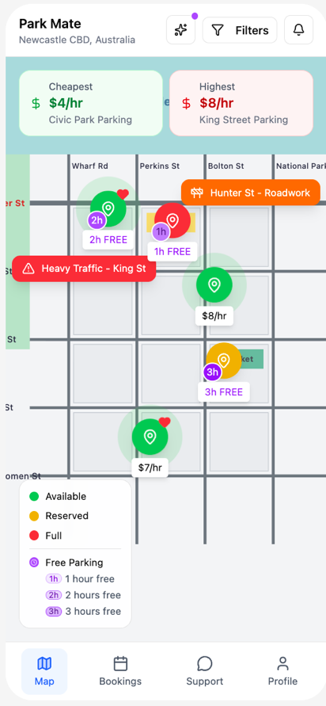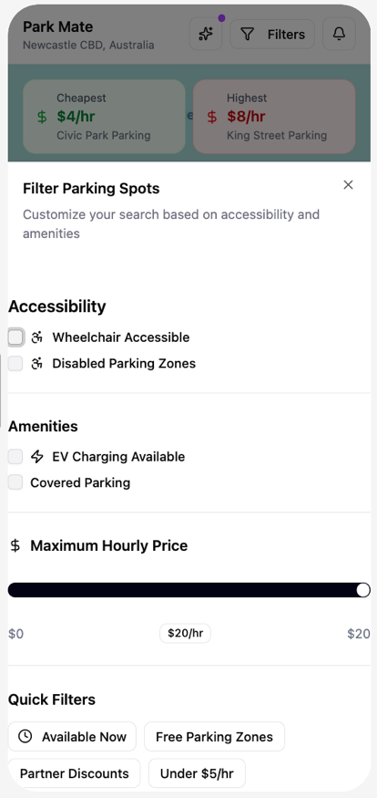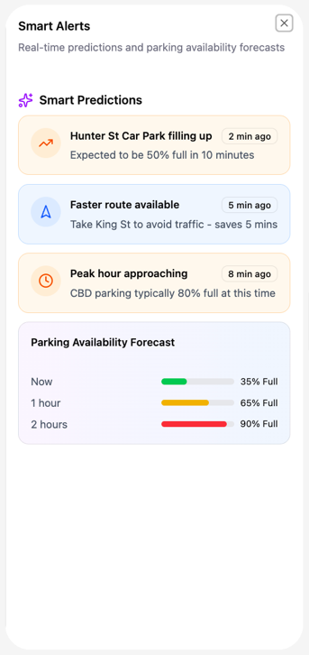
- Pre-booking and pricing (Figures below): Users could view specific parking rates, availability and amenities by hour, day or month in a parking area. The AI feature predicts the probability of finding a space at specific period. Besides, customers could pre-book parking spot, duration and date, apply discounts if available (e.g., student discount) as well as access Google Maps easily.
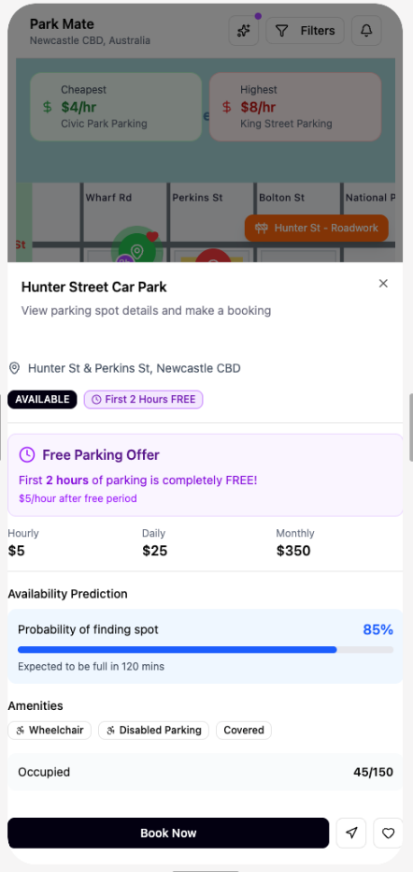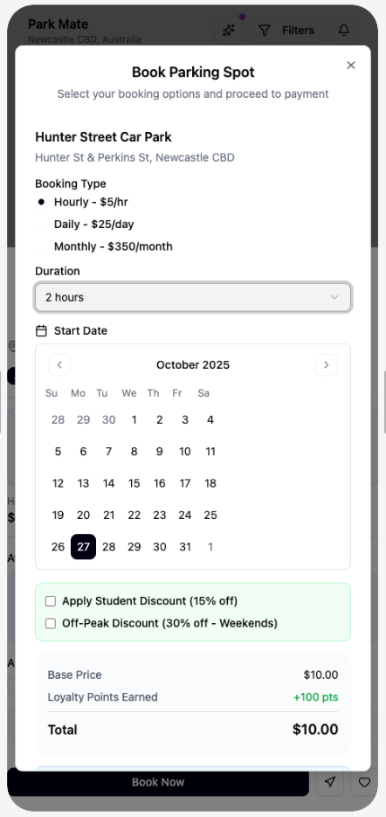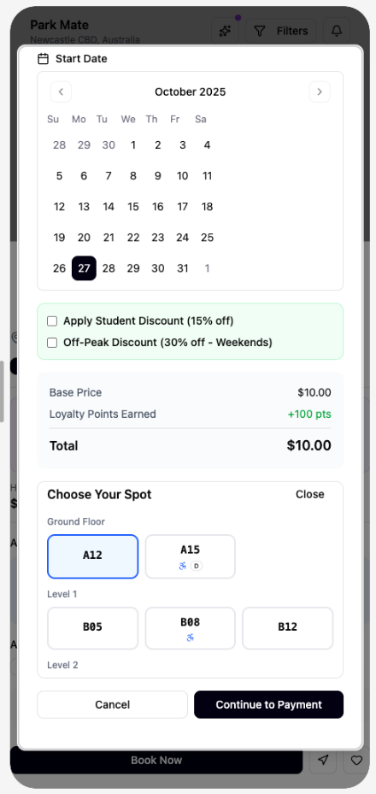
- Booking History and Favorites: A section allows users to view their booking history, access favorite locations and easily rebook frequently previous parking spaces.
- Booking extension and cancellation: Users could extend or cancel their bookings directly through Park Mate. However, fines or refunds might be applied and processed automatically following platform policies, with refunds back to the original payment method.
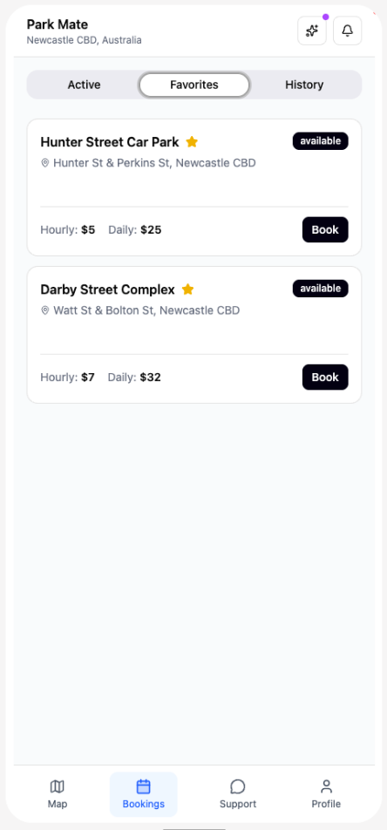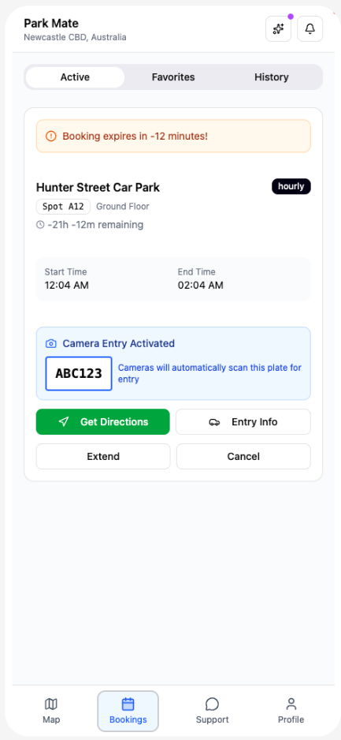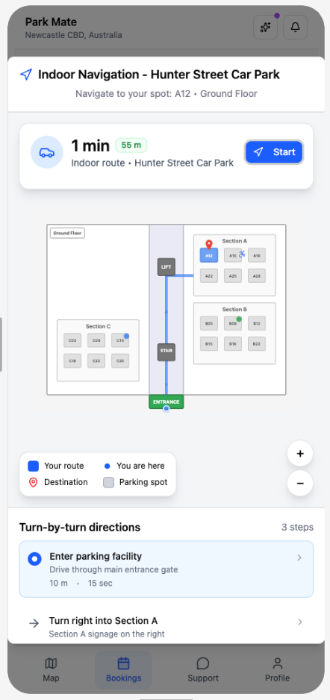
- 24/7 Chatbot Assistance: An intelligent multilingual chatbot is available 24/7 to answer frequently asked questions and support users in resolving common issues.
- Various vehicle registration: Drivers could register numerous vehicles for parking reservation.
- Different payment options: The app supports multiple payment methods, including PayPal, Apple Pay and credit cards stored in the user’s profile for fast, cashless transactions.
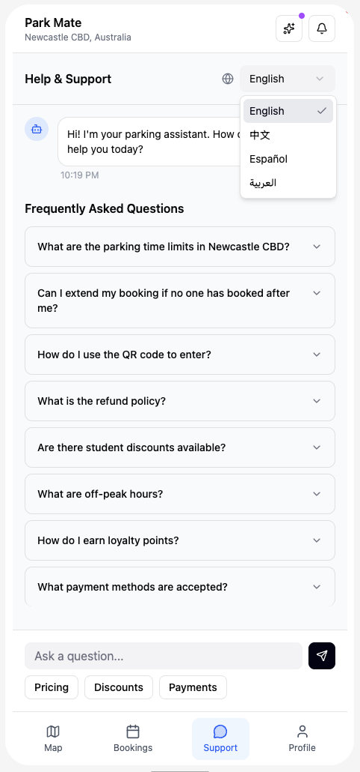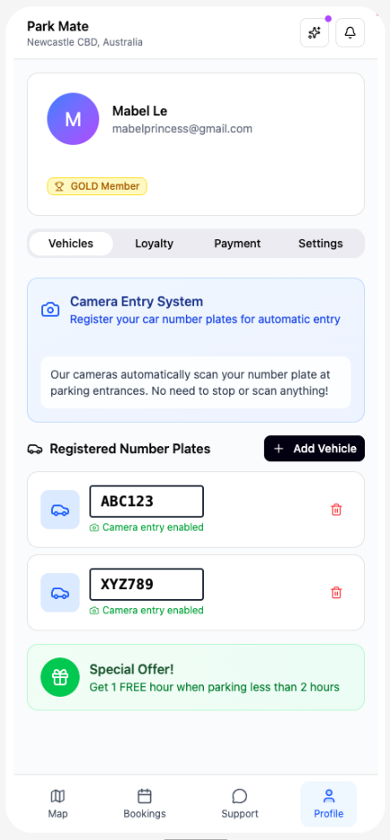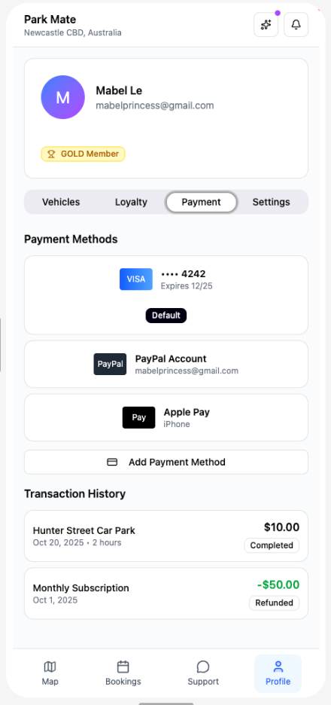
- Rewards Program: Reward points are collected in each booking or referral to friends. Redeem discounts such as birthday offers or partner cafe coupons are activated basing on membership tiers (e.g., Silver, Gold) and additional events.
- Subscription Plans: Flexible subscription options are available for users who require long-term or regular parking access with more affordable price.
- Account Setting: Users could customize some Park Mate’s user interface, verify student status for discounts and read policy details within the settings menu.
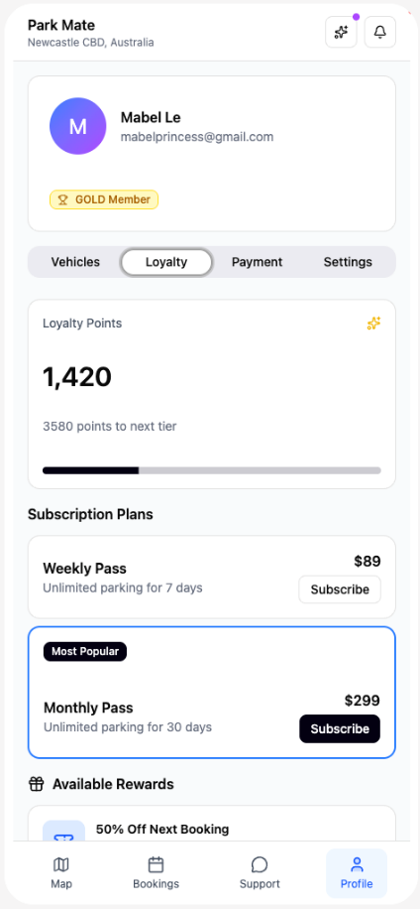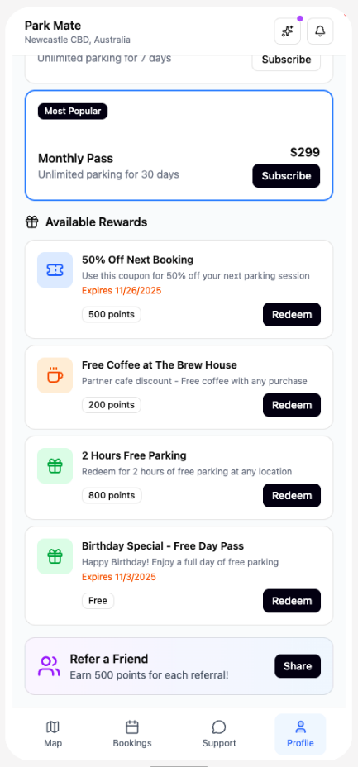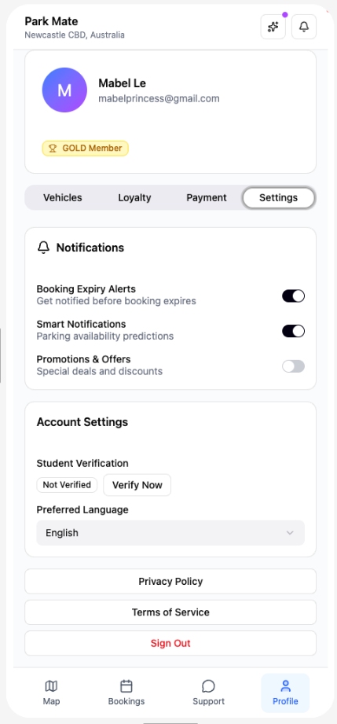

Benefits to Stakeholders
The Park Mate mobile app delivers real-time value to multiple stakeholders in the smart city ecosystem. For drivers, real-time parking, transparent pricing, and integrated payments reduce the time and stress associated with finding and managing parking spaces. Predictive features also improve convenience and overall satisfaction. Additionally, parking operators benefit from increased occupancy rates, optimized pricing, and higher revenues through digital transactions. For local councils, the system supports congestion reduction and environmental sustainability by reducing unnecessary driving. The analytics generated provide insights that inform future parking infrastructure planning and policy development.

Park Mate enhances the quality of urban life by improving access to commercial areas and encouraging economic activity. Overall, the application creates a common good through efficiency, inclusivity, and smarter traffic management.

RECOMMENDATION
To ensure the successful implementation of Park Mate, it is recommended that strategic partnerships with local governments and private parking operators be prioritized to provide accurate, real-time data and support future scalability. Improved AI-based prediction will enhance the ability to predict parking availability and reduce congestion, creating a more efficient mobility ecosystem. Additionally, an integrated user feedback system should be developed to continuously improve usability and accessibility as the application evolves. These actions are consistent with current smart parking research, which emphasizes the importance of system integration and data analytics in improving operational performance and user satisfaction (Biyik et al., 2021).

CONCLUSION
The research investigated how user-centered design methods would solve the increasing parking efficiency challenges that Australia cities face. The Design Thinking framework enabled the project to move from user empathy to problem definition and then to innovative solution development and finally to the creation of a functional Park Mate application. The solution development process used each stage to enhance user pain point understanding while creating a system that combines real-time data with automated features and digital user benefits. The research shows that human-centered smart parking systems create better user experiences and enhance parking management performance for service providers. The development of Park Mate demonstrates how empathy combined with creative thinking and technological implementation leads to a workable solution which fulfills the goals of sustainable urban transportation systems.

REFERENCES
Battaglia, D., & Battaglia, D. (2025, April 17). Finding Parking in Australia is Hectic Now. Rent Car Parking Spaces near Me | Parking Made Easy. https://www.parkingmadeeasy.com.au/blog/australians-spend-3120-hours-their-life-looking-parking
Bender-Salazar, R. (2023). Design thinking as an effective method for problem-setting and needfinding for entrepreneurial teams addressing wicked problems. Journal of Innovation and Entrepreneurship, 12(1). https://doi.org/10.1186/s13731-023-00291-2
Biyik, C., Allam, Z., Pieri, G., Moroni, D., O’Fraifer, M., O’Connell, E., Olariu, S., & Khalid, M. (2021). Smart Parking Systems: Reviewing the Literature, Architecture and Ways Forward. Smart Cities, 4(2), 623–642. https://doi.org/10.3390/smartcities4020032
Bray, T. (2023, January 27). BuildFire. Buildfire. https://buildfire.com/build-profitable-mobile-app/?fbclid=IwY2xjawNtDs1leHRuA2FlbQIxMABicmlkETFLcXVMNEI1QjZFVEtCdTVXAR5cRsKDwT70Jq_a5qVuye7h5LfOzcx6x42klXaEmaY3c734Y5EGZ5krlLaHpA_aem_6CzOPPvIC2-iCeny7WlEjw
Brown, T., & Wyatt, J. (2010). Design Thinking for Social Innovation (SSIR). Ssir.org. https://ssir.org/articles/entry/design_thinking_for_social_innovation
City of Newcastle. (2013). Parking. City of Newcastle. https://newcastle.nsw.gov.au/living/transport-and-parking/parking
City of Newcastle. (2023). Parking Sensors. NewcastleCorporate. https://newcastle.nsw.gov.au/living/transport-and-parking/parking/parking-sensors
City of Newcastle. (2025). City of Mobility. NewcastleCorporate. https://newcastle.nsw.gov.au/business/our-economic-vision/smart-city-strategy/city-of-mobility
Dam, R. F. (2025). The 5 Stages in the Design Thinking Process. Interaction Design Foundation; IxDF. https://www.interaction-design.org/literature/article/5-stages-in-the-design-thinking-process
Kwon, J., Choi, Y., & Hwang, Y. (2021). Enterprise Design Thinking: An Investigation on User-Centered Design Processes in Large Corporations. Designs, 5(3), 43. https://doi.org/10.3390/designs5030043

